

**Form 10-10EZR  
Health Benefits Update (Digitization)**

**Version 3.0**

**Launch: July 28, 2025**

Table of Contents

Overview and Navigation

Introduction Page

Signed-in Veterans: LOA1 (Not Identity Verified)

Signed-in Veterans: LOA3 (Identity Verified)

Filling Out the Form

Veteran Information

Step 1 of 5: Names  
 Authenticated Veteran

Step 1 of 5: Mailing Address

Step 1 of 5: Phone and Email

Step 1 of 5: Emergency Contact

Step 1 of 5: Next of Kin

Military Service

Step 2 of 5: Military Status

Military Service: Page 1

Military service page 2: Cleanup or response efforts

Military service page 3: Service in Gulf War locations

Military service page 4: Service dates for Gulf War locations  
Military service page 5: Operations

Military service page 6: Agent Orange locations

Military service page 7: Other toxic exposures

Military service page 8: Other unlisted toxic exposure

Military service page 9: Dates of exposure

Household Information

Step 3 of 5: Marital status

Step 3 of 5: Spouse’s personal information

Step 3 of 5: Spouse’s additional information

Step 3 of 5: Spouse’s financial support

Step 3 of 5: Dependent’s information

Step 3 of 5: Dependent’s personal information

Step 3 of 5: Dependent’s education expenses

Step 3 of 5: Dependent’s additional information

Step 3 of 5: Dependent’s annual income (previous year)

Review Your Dependents

Step 3 of 5: Annual income

Step 3 of 5: Previous calendar year deductible expenses

Insurance Information

Step 4 of 5: Medicaid

Step 4 of 5: Medicare

Step 4 of 5: Medicare detail

Step 4 of 5: Other coverage

Step 5 of 5: Review

Health Benefits Update Form Troubleshooting

Questions About the Content of the Form

The Form is Pre-filled With Incorrect Information

The Veteran Can’t Move Forward in Their Form

The Veteran is Having Trouble Upgrading From LOA1 to LOA3

# Overview and Navigation

VA.gov Veterans can update their health care benefits information by filling out the online VA Form 10-10EZR, the Health Benefits Updates Form. Veterans with an LOA1 account (not identity verified) or an LOA3 account (identity verified) can access and complete the Health Benefits Update Form.

A Veteran can find the Health Benefits Update Form at <https://www.va.gov/health-care/update-health-information> or

* On the VA.gov VA health care page at [www.va.gov/health-care](http://www.va.gov/)

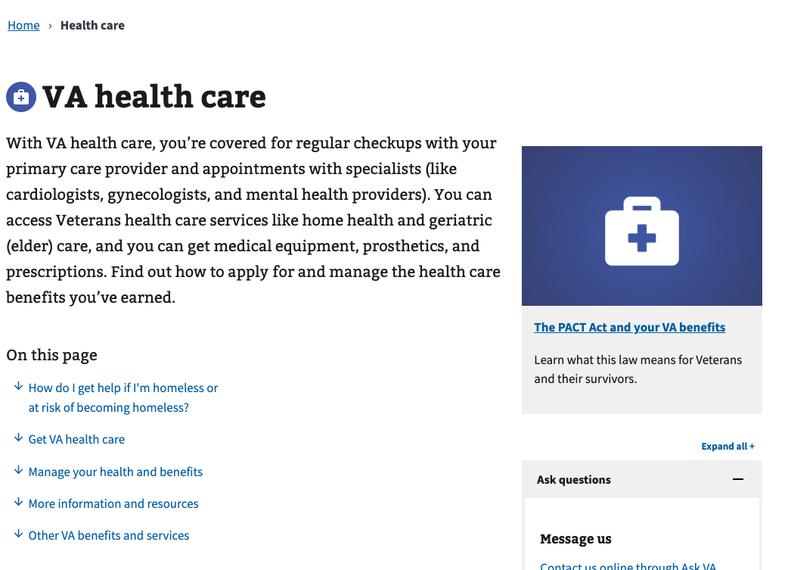

* In the VA health care benefit hub: <https://www.va.gov/health-care/>

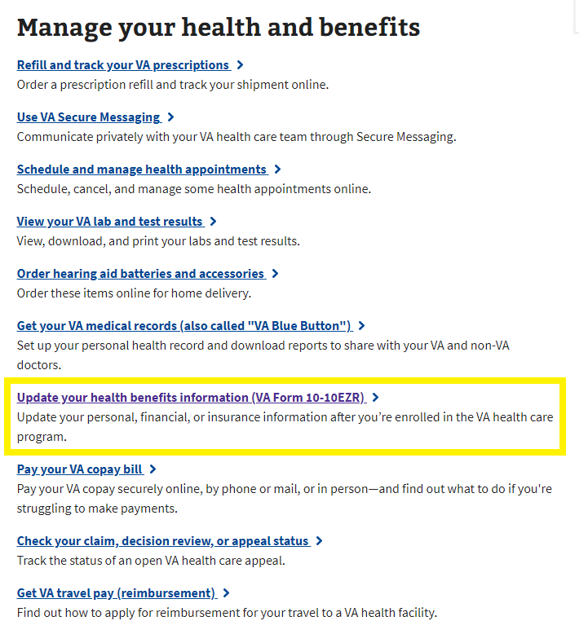

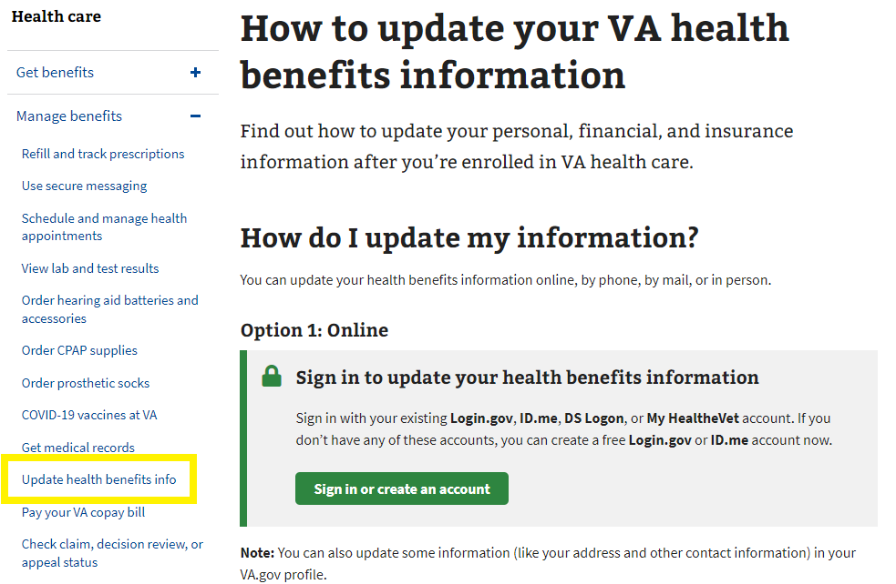

* In the My HealtheVet hub: <https://www.va.gov/my-health/>

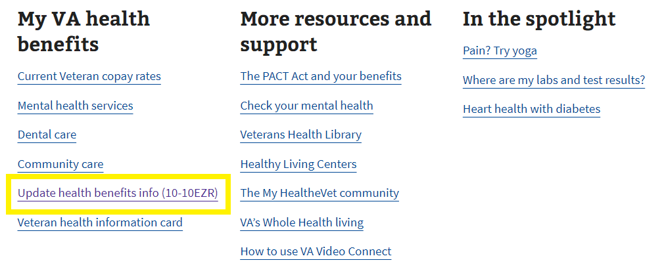

# Introduction Page

Currently, the Update Health Benefits form is available on VA.gov (<https://www.va.gov/my-health/update-benefits-information-form-10-10ezr/introduction>) for signed-in Veterans who visit the site and are enrolled in VA health care, regardless of whether they are LOA1 or LOA3.

Unauthenticated Veterans will be prompted to sign in to update their information online.

## 

## Signed-in Veterans: LOA1 (Not Identity Verified)

Signed-in LOA1 Veterans will see the following alert when they visit the Health Benefits Update Form introduction page at <https://www.va.gov/my-health/update-benefits-information-form-10-10ezr/introduction>. LOA1 Veterans won’t be able to access the Health Benefits Update Form without first verifying their identity and becoming LOA3. This identification process ensures that all Veterans who apply are scanned through the ESR to confirm whether they are enrolled in VA health care.

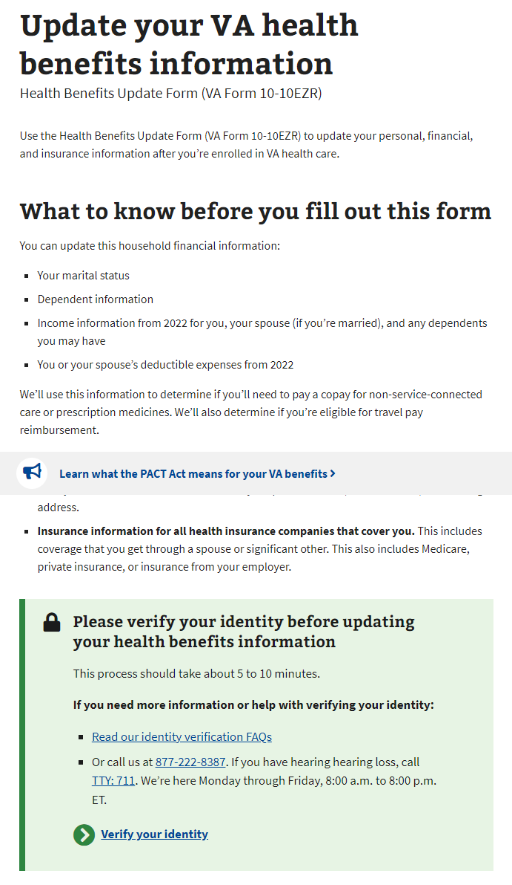

## Signed-in Veterans: LOA3 (Identity Verified)

For signed-in LOA3 Veterans, we will automatically perform a scan on the backend for existing health care records in the enrollment system (ESR) when they go to the form introduction page at https://www.va.gov/my-health/update-benefits-information-form-10-10ezr/introduction

For Veterans not found in the ESR, they will not be able to go straight into the Health Benefits Update form and instead will see a message advising them to apply for health care with a link to the Veteran health care application (10-10EZ):

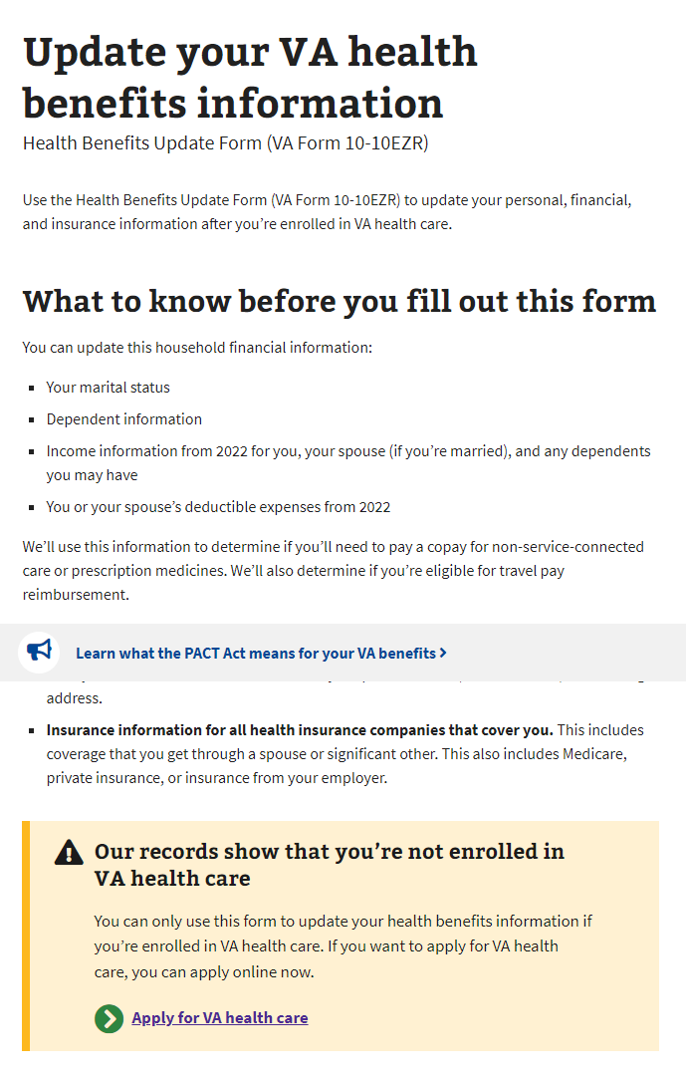

For Veterans found in the ESR, they will fill out the Health Benefits Update form.  
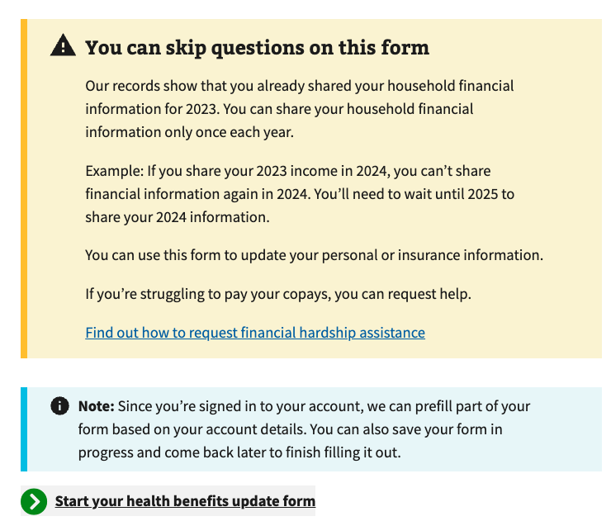

# Filling Out the Form

There are 5 sections in the Health Benefits Update Form:

1. Veteran information.
2. Military information (including toxic exposure)
3. Household information.
4. Insurance information.
5. Form review.

Note: The system will prefill some of the information on file. Veterans can review and update some of this information as they complete the form.

Each section contains multiple pages of questions that the Veteran must complete to enter the information required to fill out the form. The form automatically saves as the Veteran progresses, and they can choose to “Finish this form later” if needed.

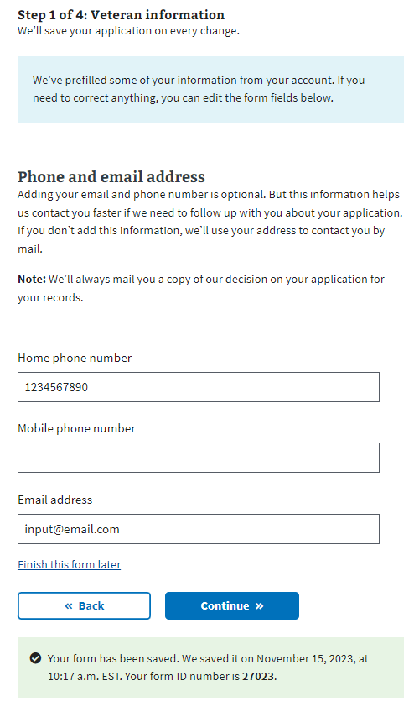

To move forward through the form, the Veteran clicks “Continue.” They cannot move forward until all required information on the page is complete. An example error message is shown below. To return to a previous section of the form, the Veteran can use the back button.

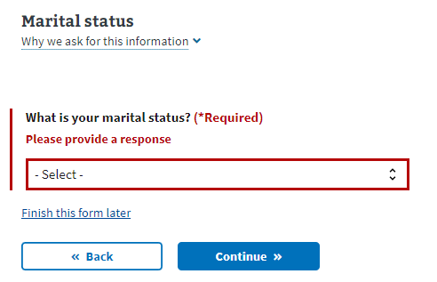

The form also features a status bar at the top of each page to indicate a Veteran's progress through the form. It progresses when a new section is complete, not based on the number of questions completed:

## 

## Veteran Information

### Step 1 of 5: Names

Veterans are shown their name, DOB, and Social Security number in a locked state. If they need to update this information, they must contact the VA Benefits Hotline at 1-800-827-1000.

Authenticated Veteran

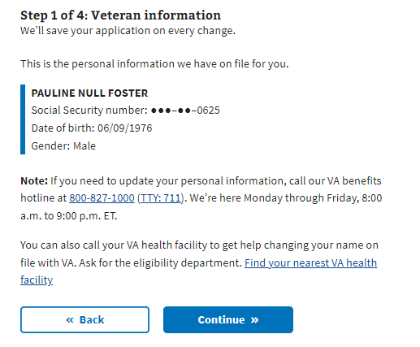

### Step 1 of 5: Mailing Address

If the Veteran indicates that their mailing address is different from their home address, they must enter their home address on the following page.

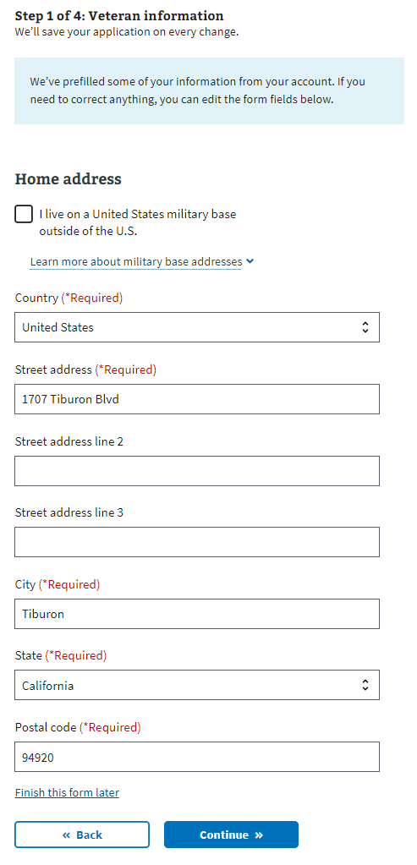

### Step 1 of 5: Phone and Email

Veterans may provide their email addresses and home/mobile telephone numbers. If the Veteran shares this information, VA uses it to communicate with the Veteran during the form process. If they don’t provide either, correspondence is sent via postal mail.

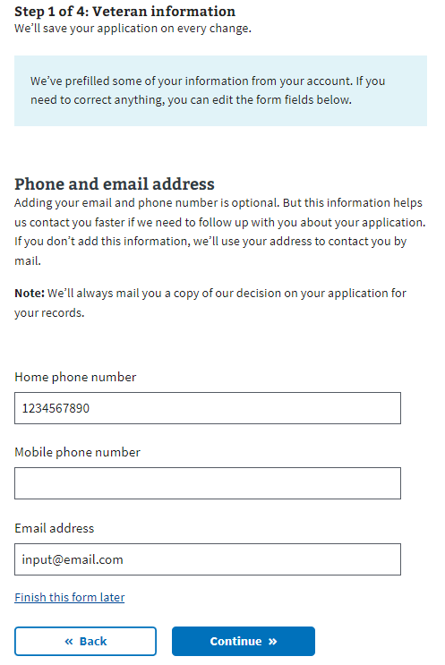

### Step 1 of 5: Emergency Contact

Veterans may provide their emergency contact information. If the Veteran already has one in their health record, that information will display, and the Veteran will have the option to edit or remove the contact. If no emergency contact is listed on the health record, and the Veteran does not wish to add one, they can select “No” and then “Continue” to proceed to the next question.

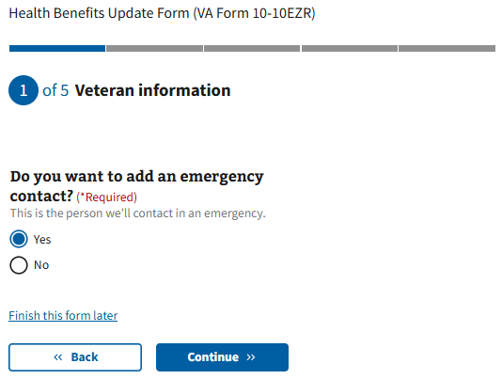

The Veteran will be asked for the emergency contact’s name, phone number, and relationship.

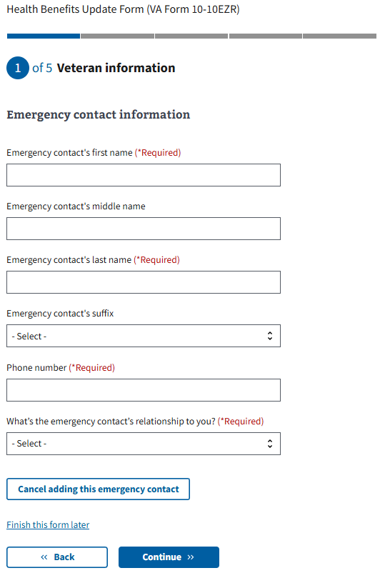

The Veteran may choose to cancel while still in the process of adding an emergency contact. This will remove any information input and will not be saved.

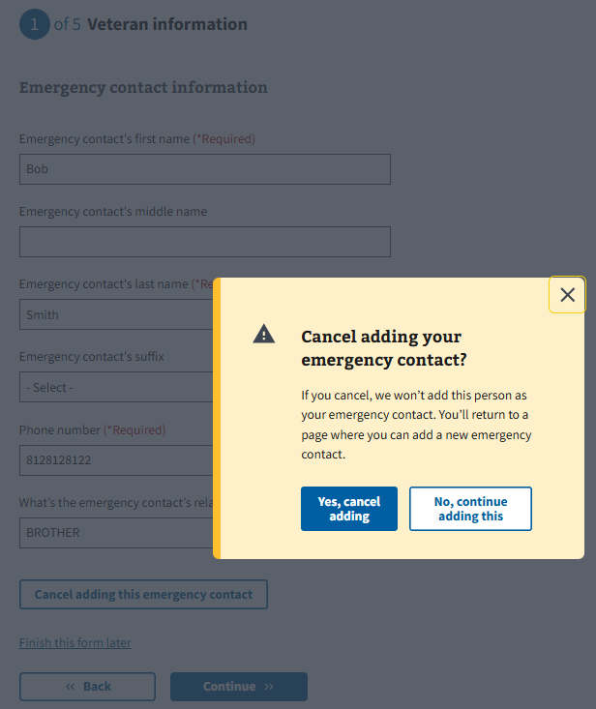

The Veteran will be asked to provide the emergency contact’s address.

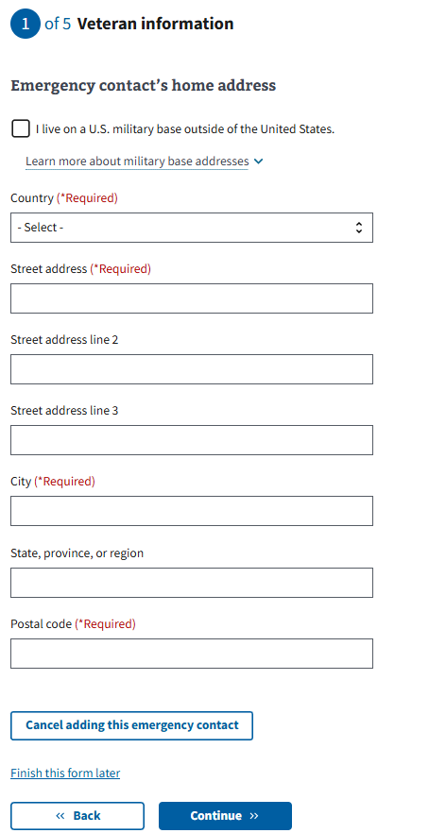

Once the Veteran has added an emergency contact, or if an emergency contact was already on the Veteran’s health care record, it will be displayed on the screen. The Veteran has the option to edit or delete the contact.

If the Veteran does not want to edit or delete the contact, they can select Continue to move on to the next question.

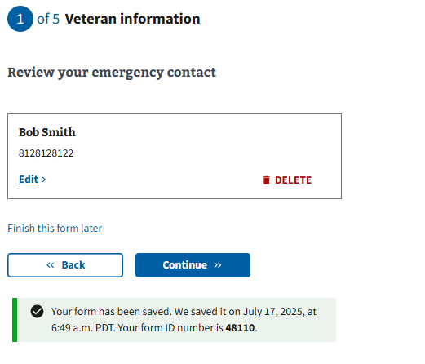

While editing the emergency contact, the Veteran may choose to cancel out of the editing screen. This will remove any changes made and will retain the original emergency contact information.

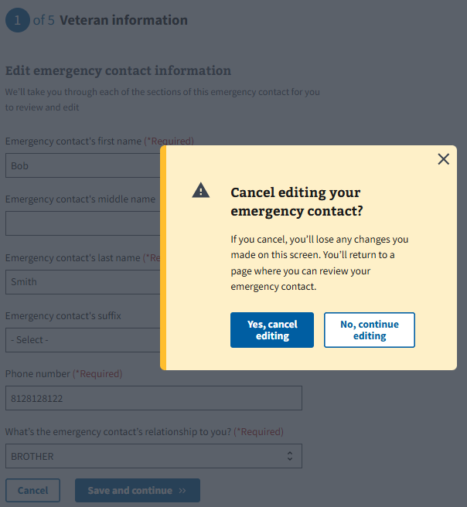

If the Veteran chooses to delete their emergency contact, the information will be removed from both the form and their health record. They will then be asked if they want to add an emergency contact. The Veteran can either add a new one or continue without identifying an emergency contact.

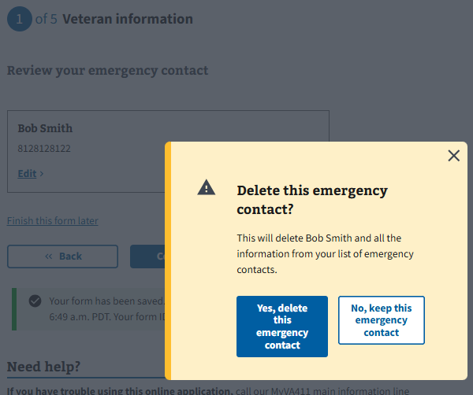

### Step 1 of 5: Next of Kin

Veterans may provide their next of kin information. If the Veteran already has one in their health record, that information will display, and the Veteran will have the option to edit or remove the contact. If no next of kin is listed on the health record, and the Veteran does not wish to add one, they can select “No” and then “Continue” to proceed to the next question.

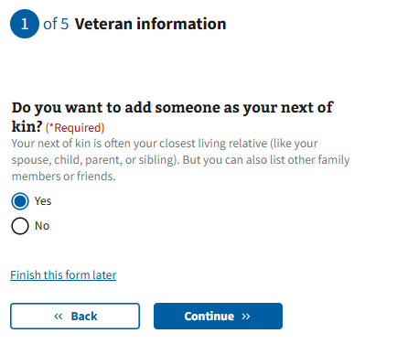

The Veteran will be asked for the next of kin’s name, phone number, and relationship:

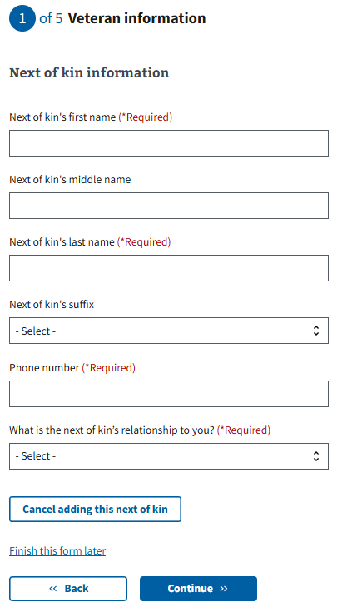

The Veteran may choose to cancel while still in the process of adding a next of kin. This will remove any information input and will not be saved.

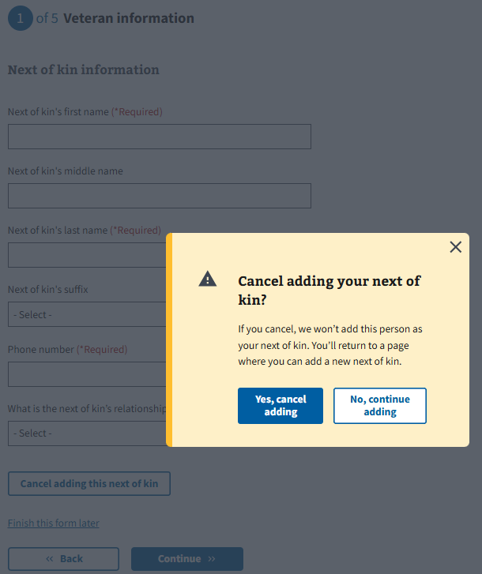

The Veteran will be asked to provide the next of kin’s address.

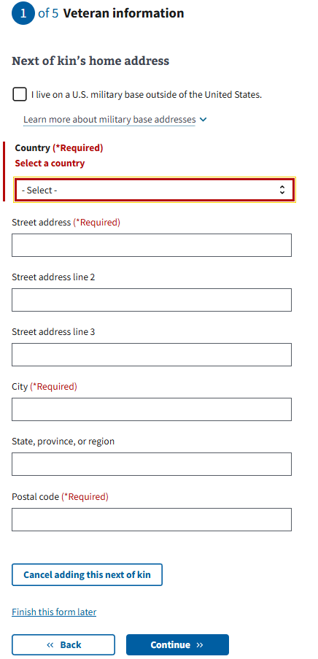

Once the Veteran has added a next of kin, or if a next of kin was already on the Veteran’s health care record, they will be displayed on the screen. The Veteran has the option to edit or delete the contact.

If the Veteran does not want to edit or delete the contact, they can select Continue to move on to the next question.

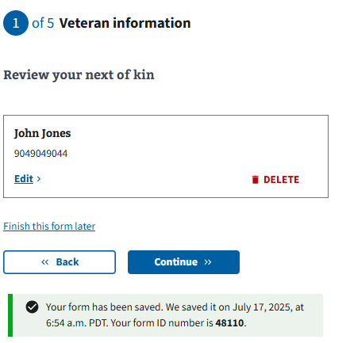

While editing the next of kin, the Veteran may choose to cancel out of the editing screen. This will remove any changes made and will retain the original next of kin information.

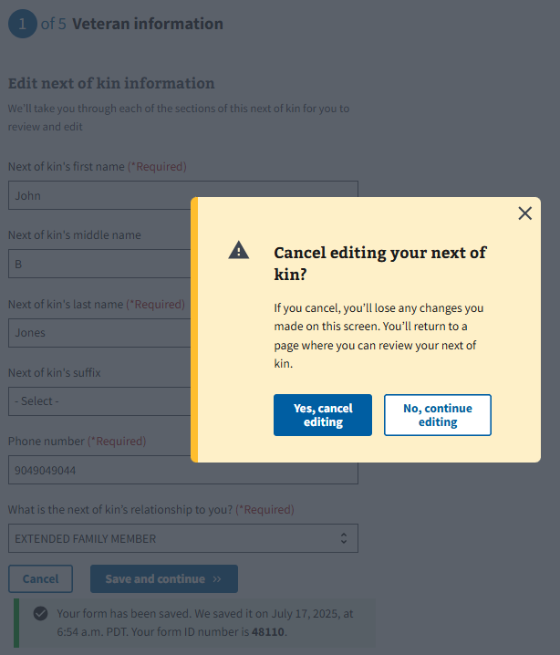

If the Veteran chooses to delete their next of kin, the information will be removed from both the form and their health record. They will then be asked if they want to add a next of kin. The Veteran can either add a new one or continue without identifying a next of kin.

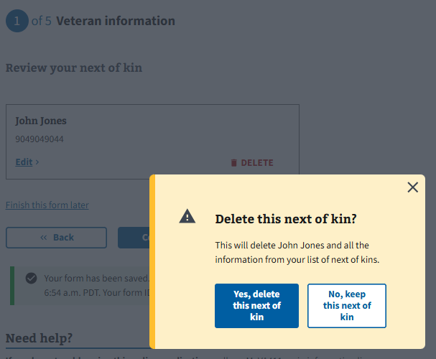

Military Information

### 

### Step 2 of 5: Military Service

Military Service: Page 1

This page explains toxic exposure and provides resources that Veterans might want to access to learn more. A Veteran can choose whether or not to answer questions regarding military service history and any toxic exposure (or potential toxic exposure). The following questions address specific locations and operations where Veterans may have been exposed to toxins.

## 

### Military service page 2: Cleanup or response efforts

Veterans can indicate whether they participated in any cleanup or response efforts on this page.

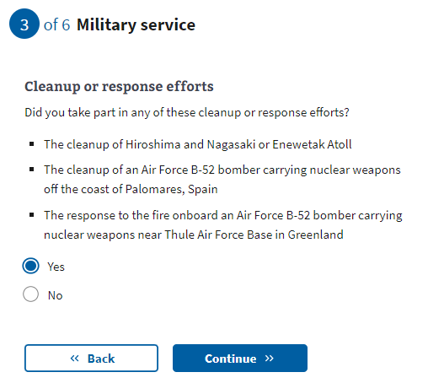

Military service page 3: Service in Gulf War locations

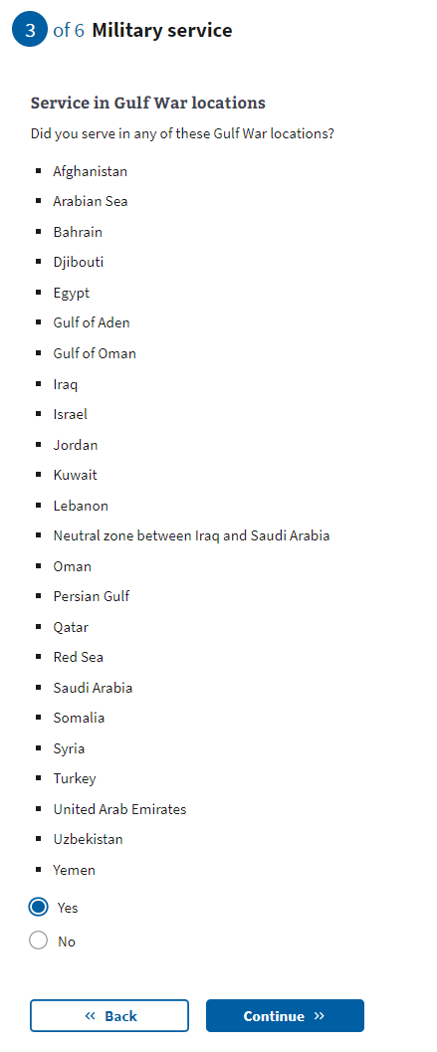

[Military service page 4:](https://docs.google.com/document/d/1q11ictK4zNJR4xZSBCcdndDI_PTItqzqFKfw8N3c1cA/edit?pli=1#bookmark=id.19c6y18) Service dates for Gulf War locations

These date fields are optional. If they know this information, Veterans can provide a month, year, or date range. If the Veteran does not know or does not want to estimate a date or range, they can leave these optional fields blank and continue to the next page.

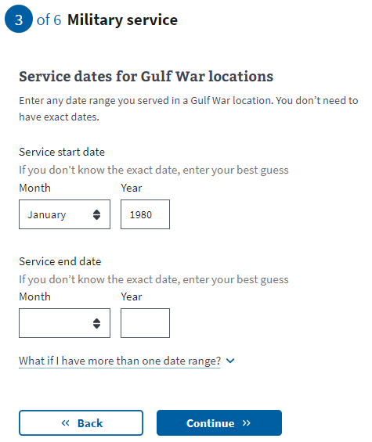

[Military service page 5:](https://docs.google.com/document/d/1q11ictK4zNJR4xZSBCcdndDI_PTItqzqFKfw8N3c1cA/edit?pli=1#bookmark=id.19c6y18) Operations

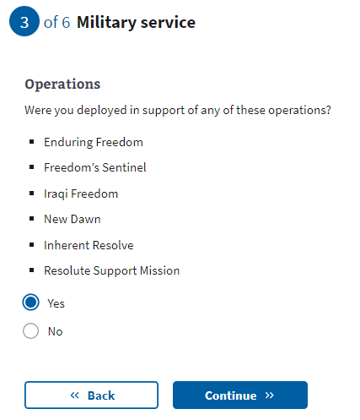

[Military service page 6:](https://docs.google.com/document/d/1q11ictK4zNJR4xZSBCcdndDI_PTItqzqFKfw8N3c1cA/edit?pli=1#bookmark=id.19c6y18) Agent Orange locations

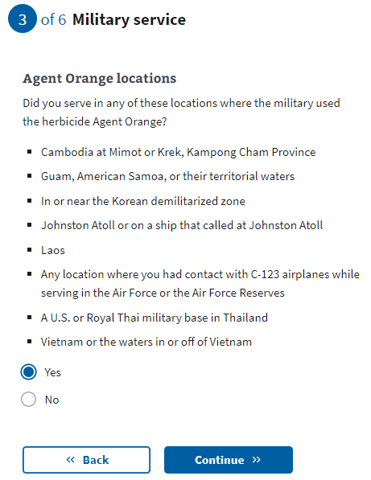

[Military service page 7:](https://docs.google.com/document/d/1q11ictK4zNJR4xZSBCcdndDI_PTItqzqFKfw8N3c1cA/edit?pli=1#bookmark=id.19c6y18) Other toxic exposures

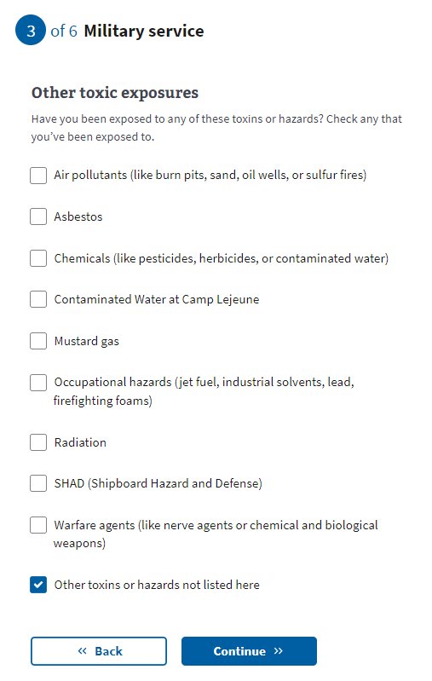

[Military service page 8: Other unlisted toxic](https://docs.google.com/document/d/1q11ictK4zNJR4xZSBCcdndDI_PTItqzqFKfw8N3c1cA/edit?pli=1#bookmark=id.19c6y18) exposure

If the Veteran selects “Other toxins or hazards not listed here” from the previous question, they will be asked to list the toxin(s) to which they may have experienced exposure.

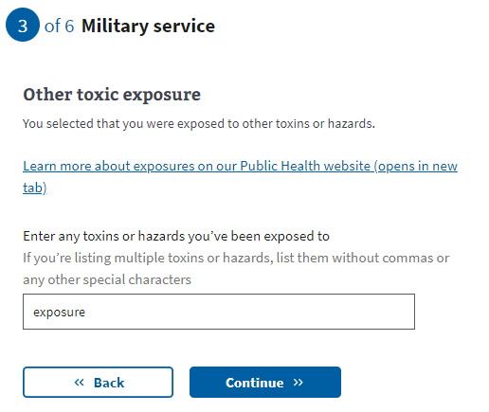

[Military service page 9: Dates of](https://docs.google.com/document/d/1q11ictK4zNJR4xZSBCcdndDI_PTItqzqFKfw8N3c1cA/edit?pli=1#bookmark=id.19c6y18) exposure

These date fields are optional. If they know this information, Veterans can provide a month, year, or date range. If the Veteran does not know or does not want to estimate a date or range, they can leave these optional fields blank and continue to the next page.

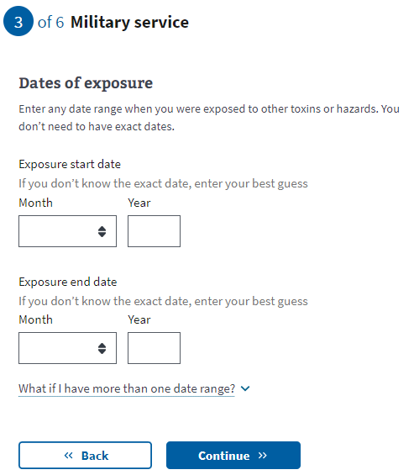

## Household Information

### 

### Step 3 of 5: Marital status

The Veteran will now need to indicate their marital status from the drop-down.

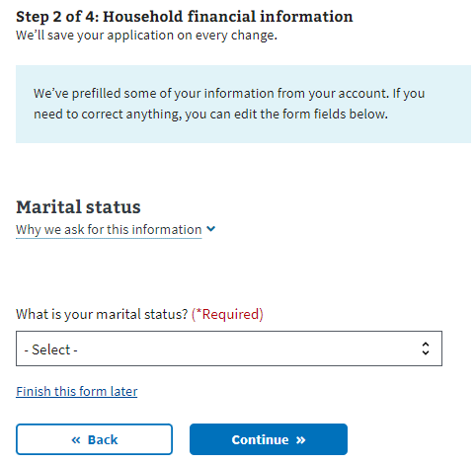

### Step 3 of 5: Spouse’s personal information

If the Veteran has indicated they are married or separated, they must fill out their spouse’s information.

They must complete the insurance information section next if they have indicated that they have never been married, divorced, or widowed.

### 

### Step 3 of 5: Spouse’s additional information

The Veteran must specify whether their spouse lived with them during the previous year and whether they currently live with them. This information will help determine whether the spouse should be considered a dependent for tax purposes.

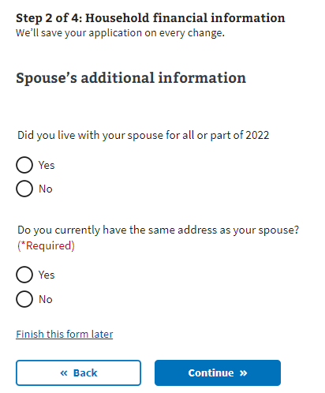

### Step 3 of 5: Spouse’s financial support

If the Veteran indicates that they did not live with their spouse the previous year, they must specify whether they provided financial support to their spouse.

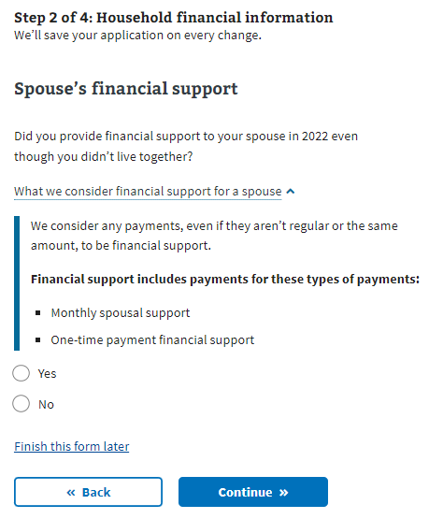

### Step 3 of 5: Dependent’s information

If the Veteran wants to add their dependent, the form will ask them to input information about that person. They will have the option to enter more than one dependent.

Examples of when someone becomes your dependent:

* **Birth of a child**: The DOB would be the date the child became your dependent.
* **Adoption**: The official date of adoption would be the date on which the child became your dependent.

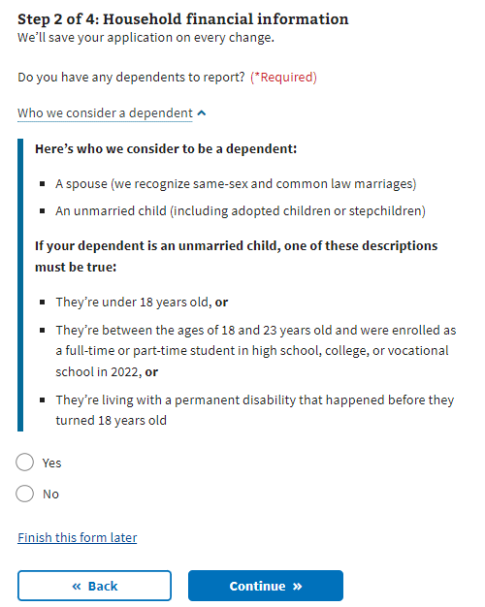

### Step 3 of 5: Dependent’s personal information The Veteran must provide the dependent’s information. All required fields must be completed before saving the form. If the Veteran exits before completing the necessary fields for the dependent, the form won’t save, and they’ll have to re-enter the data.

### 

### Step 3 of 5: Dependent’s education expenses

The Veteran must provide information on education expenses if the dependent is between 18 and 23 years old.

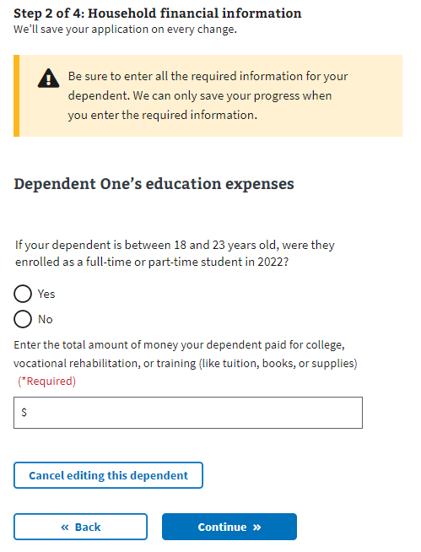

### Step 3 of 5: Dependent’s additional information

The Veteran must indicate whether their dependent was permanently disabled before turning 18, whether they lived with them during the previous year, and if the dependent earned any income during the last year.

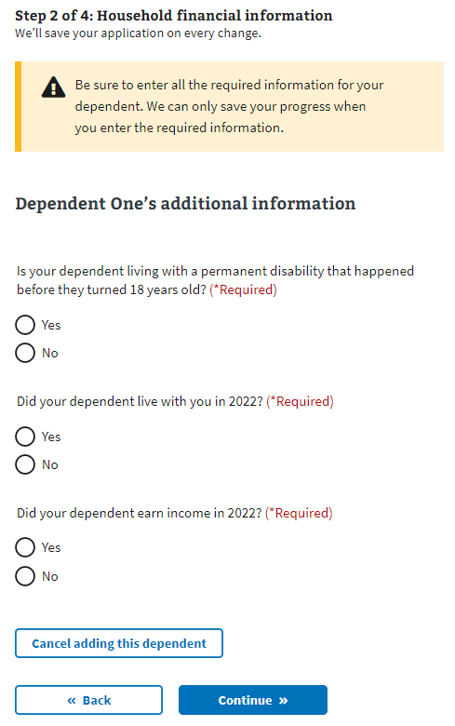

### Step 3 of 5: Dependent’s annual income (previous year)

If the Veteran indicates that their dependent earned income during the previous year, the form requires details of that income.

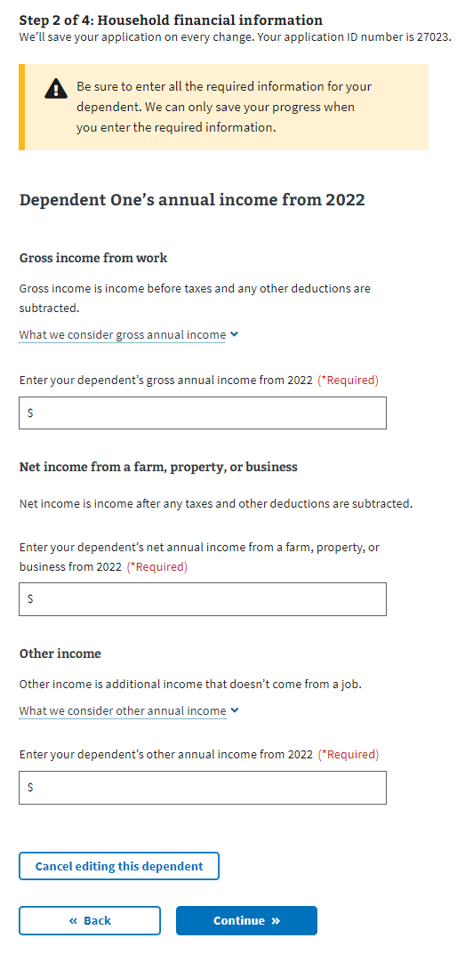

### Review your dependents

Once the Veteran has entered at least one dependent, they will see their dependent listed and be able to edit or remove the information. The Veteran can add dependents by answering “Yes” to “Do you have another dependent to report?”  
  
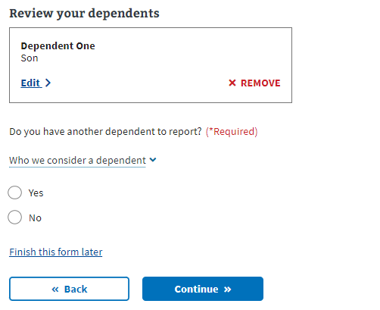

### Step 3 of 5: Annual income

The Veteran must provide the requested financial information in the following forms. The form will ask about their annual income and the deductible expenses from the previous year. If the Veteran indicated they were married, they must also disclose their spouse’s annual income.

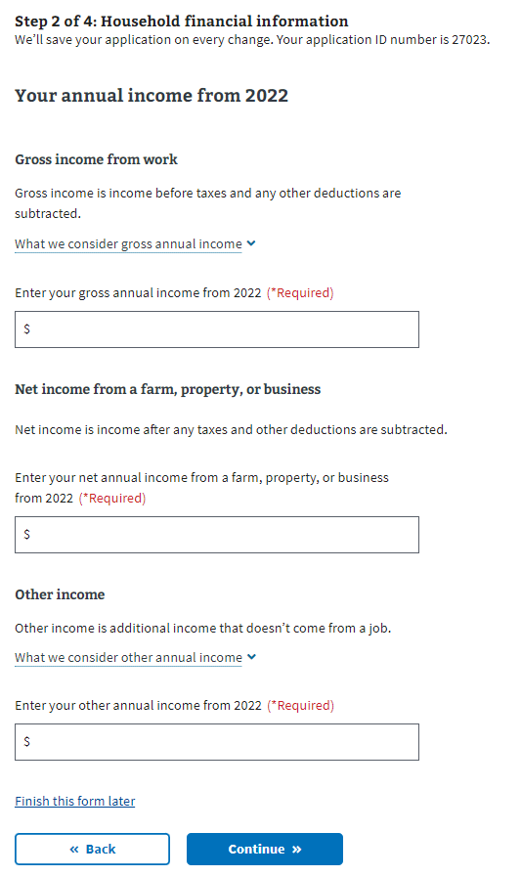

### Step 3 of 5: Previous calendar year’s deductible expenses

### 

## Insurance Information

### Step 4 of 5: Medicaid

All Veterans view this page. The Veteran needs to indicate whether they’re eligible for Medicaid.

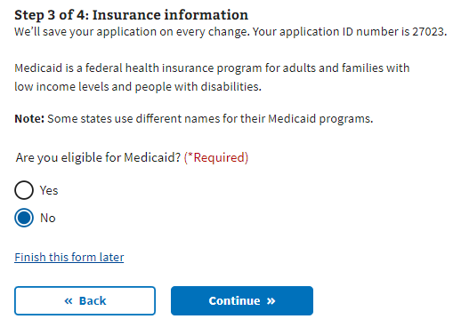

### Step 4 of 5: Medicare

If the Veteran is enrolled in Medicare Part A, they must indicate so during this step. Selecting “Yes” sends the Veteran to a page where they provide the effective date of their Medicare Part A coverage.

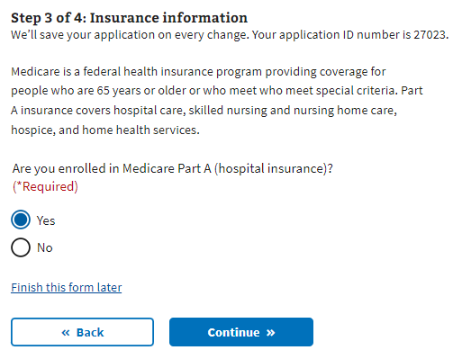

### Step 4 of 5: Medicare detail

The Veteran is required to disclose the effective date of their Medicare Part A and Medicare claim number.  
  
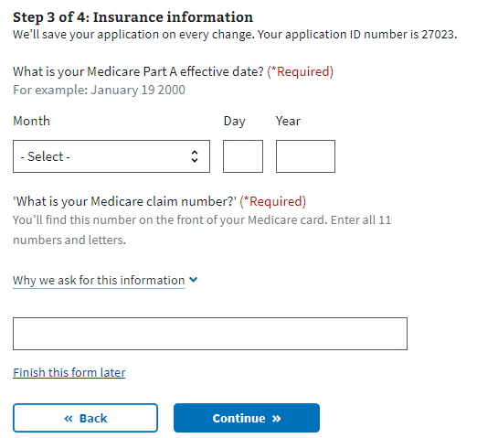

### Step 4 of 5: Other coverage

The Veteran needs to indicate whether they have any additional health insurance coverage. If they do, the Veteran must select “Continue” to proceed to the next page and input that information.

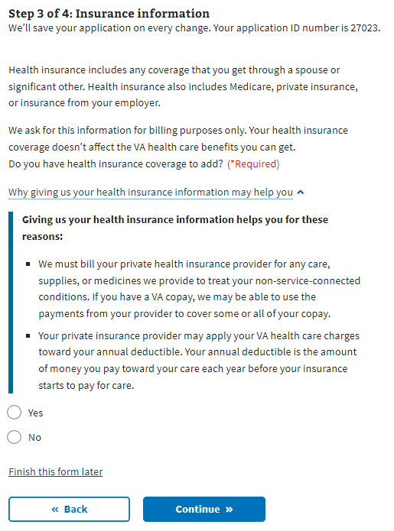

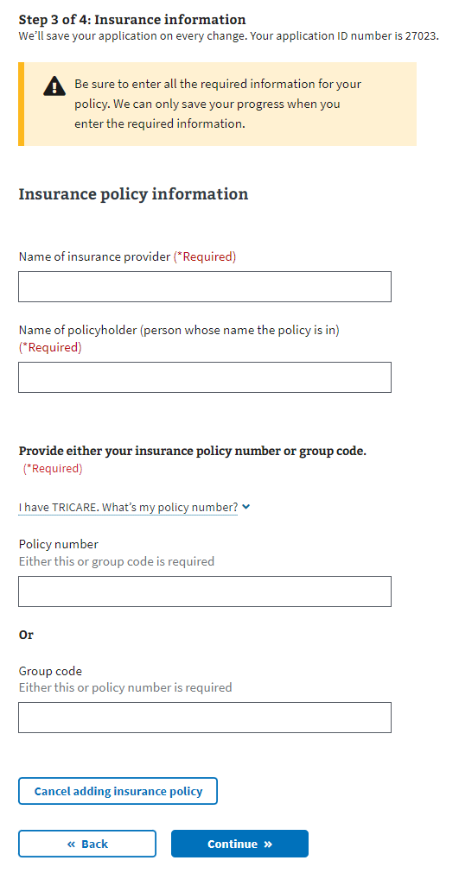

Once the Veteran has entered at least one insurance policy, they will see their insurance policy listed and can edit or remove the information. They will have the option to enter more than one insurance policy.

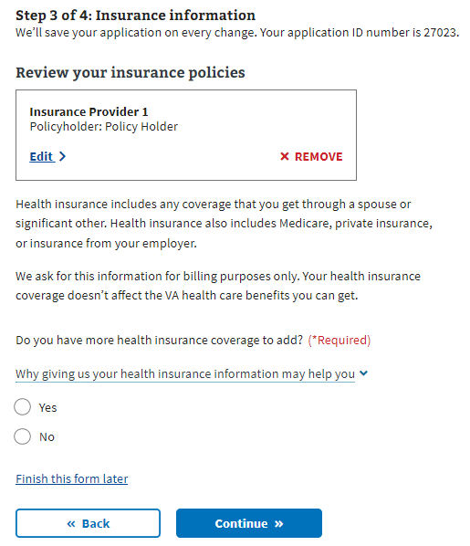

## Step 5 of 5: Review

Once the Veteran has completed the form, they will proceed to the Review step, where they can open each section and review the information they entered.

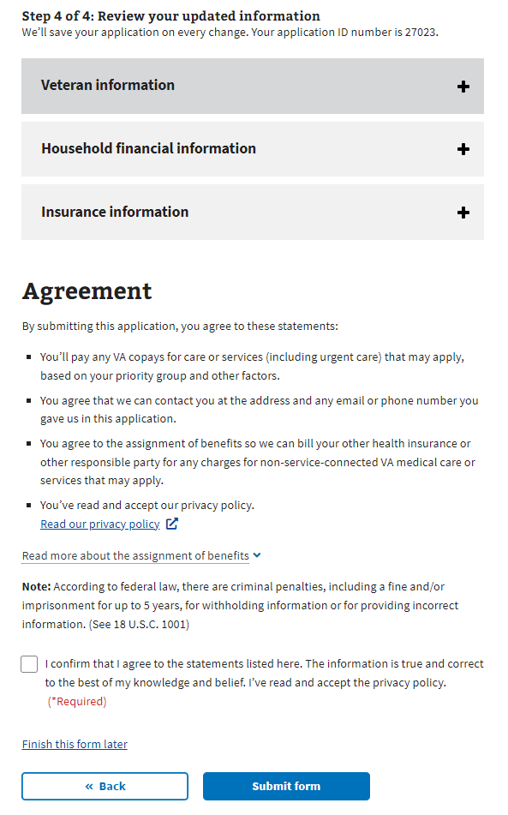

If they want to change the information shown, they can select the “Edit”button and change that information.

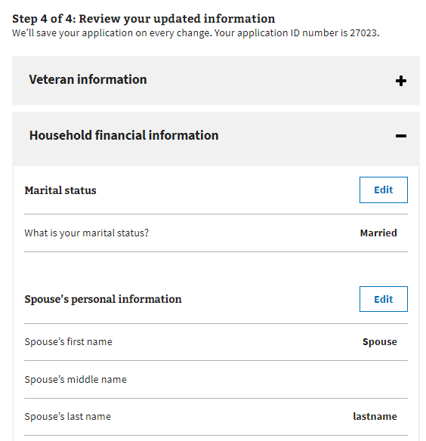

Once the Veteran presses the “Edit” button, they can update their information. They must press the “Update Page” button to save the changed data.

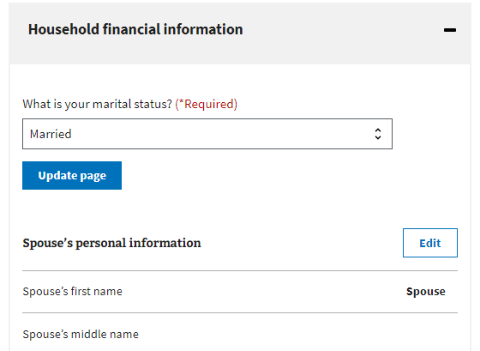

If any changes are made to remove required information or trigger additional questions, the form will draw the Veteran’s attention to where updates are needed.

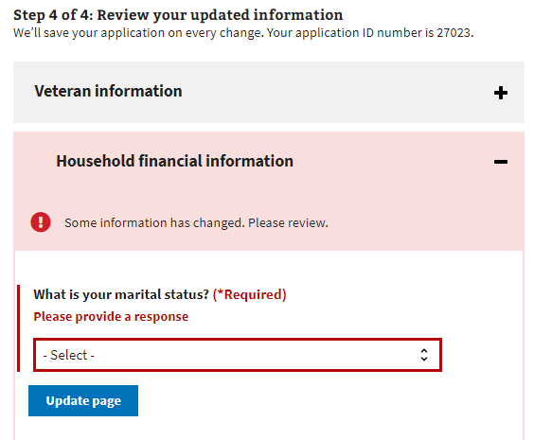

Once the Veteran has reviewed the information and is ready to submit the form, they must select the checkbox indicating that they agree to the statements listed, that the information is accurate, and that they have read and accepted the privacy policy. The privacy policy is accessible via a link to a new tab; their form won’t be interrupted.

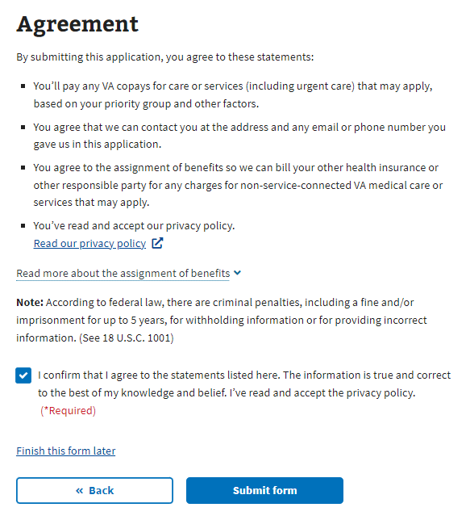

After the form is submitted, the Veteran sees the following:

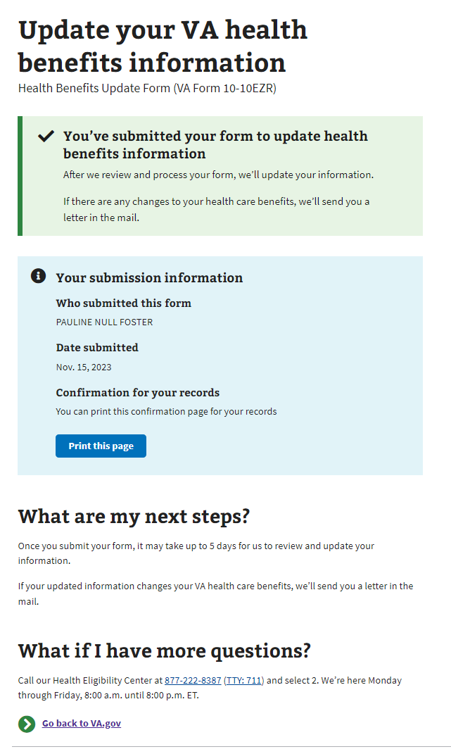

# Health Benefits Update Form Troubleshooting

## Questions about the content of the form

Many Veterans will have specific questions about the content of the form because they don’t understand what the form is asking or why it needs that information. The Health Enrollment Center (HEC) should be aware of these non-technical issues. Before transferring the Veteran to this call center, ensure they don’t have any questions related to navigation or issues entering information due to technical reasons.

The information for the HEC is at the bottom of every page in the Health Benefits Update Form:

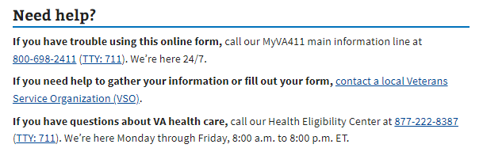

## The form is prefilled with incorrect information

If a Veteran has already entered information about themselves or their account has personal, contact, or spouse information associated with it, that information should populate the form. The purpose is to make it easier for the Veteran to complete the form. However, if the data needs to be corrected, it may need to be clarified for the Veteran. They can fix this by editing the information directly in the form.

## The Veteran can’t move forward in their form

If a Veteran says they can’t move on to the next page in the form, ask them to verify that they have filled out all the required information. The website will display red text indicating where necessary information is missing:  
  
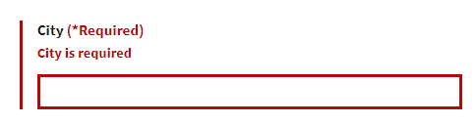

## The Veteran is having trouble upgrading from LOA1 to LOA3

If a Veteran is trying to apply for health care benefits with their LOA1 (not an identity-verified account), they will be required to upgrade to an LOA3 (identity-verified) account. They can do this using ID.me, Login.gov, or an upgraded My HealtheVet or DS Logon account. If the Veteran prefers not to do this, they can update their information over the phone or in person at their local VA facility.